


CORTE D’APPELLO DI TORINO

Visit of a delegation from
International Association of Youth and Family Judges and Magistrates (AIMJF)
International Association of Youth and Family Magistrates (AIMJF)

Monday 26th October 2026

Objective of the visit as copied for the Visit Enquiry Form:
Aims: to understand Italian legal framework, jurisdiction and procedures regarding children’s rights (child protection, juvenile justice and child victims); to understand coordination protocols between the judiciary offices and services for children; visit programs or services connected with children’s rights in these three fields (child protection, juvenile justice and child victims)

Itinerary

Monday 26th October 2026

9:20 am arrive at:
Palazzo di Giustizia – Aula Consiglio Giudiziario
Corso Vittorio Emanuele II, 130
Torino, Italy

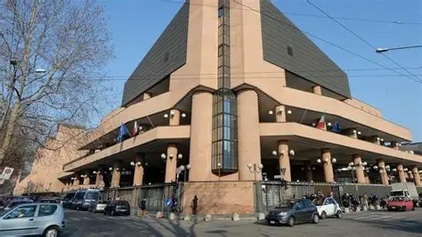

Time: | Meeting:
9:15am | At main entrance meet you Michele Termine  Phone Number: +39 347 3500925
9:30 am-10:00 am | Meet Roberta COLLIDA’, Pres. Juvenile and Family Sect. Court of Appeal  Carmen Rita MECCA, Pres. Juvenile Court  Emma AVEZZU’, Juvenile Prosecutor  And Paola ORTOLAN, AIMMF Vice President
10:30am-2:00 pm  (Light lunch 2:00pm-3:00pm) | Legal protection tools for children and adolescents in the Italian legal system  Spend the day meeting with members of the judiciary Courts: Description of judicial procedures and coordinated actions with child protection services. Visit to the courtrooms and the council chamber.
3:45 pm | Guided tour of the Cinema Museum / Mole Antonelliana.
From 6:30 pm | Free time for Dinner – City Centrum promenade.

Tuesday 27th October 2025
9:20 am arrive at:
Palazzo di Giustizia – Corte d’Appello, Sezione Minorenni e Famiglia
Corso Vittorio Emanuele II, 130
Torino, Italy

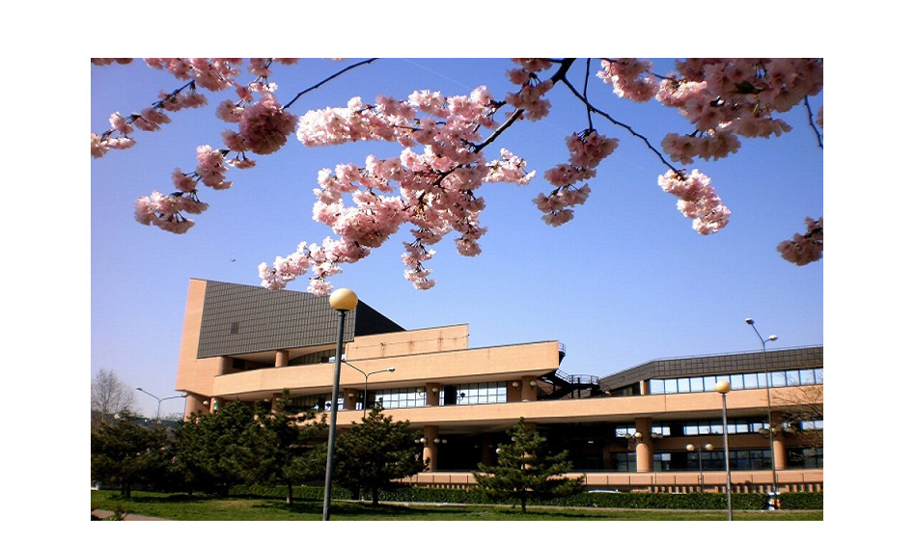

Time: | Meeting:
9:20am-10:15am | Meet Roberta COLLIDA’, President of Juvenile and Family Section of the Court of Appeal. Meeting with magistrates of the Section, focus on the judicial protection of children and adolescents
10:30am-1pm  2pm-4:30pm  (Free time for lunch 1:15pm-1:45pm) | Spend the morning with members of the judiciary, senior members of staff and observing penal proceedings in Court.  Meeting with some magistrates from the "vulnerable groups" pool of the Prosecutor's Office: discussion on the protection of minors who are victims of crime.
4:45- 6:15 pm | 4.45 pm AIMJF European section meeting
6:15pm | End of visit to Palazzo di Giustizia.

8 pm Dinner with Italians juvenile magistrates

Dinner in a typical Piedmontese restaurant

Wednesday 28th October 2025

9:20am arrive at: Tribunale per I Minorenni di Torino
Corso Unione Sovietica 325 – Torino (Tram n. 4 from City Centre, Stop Tazzoli)

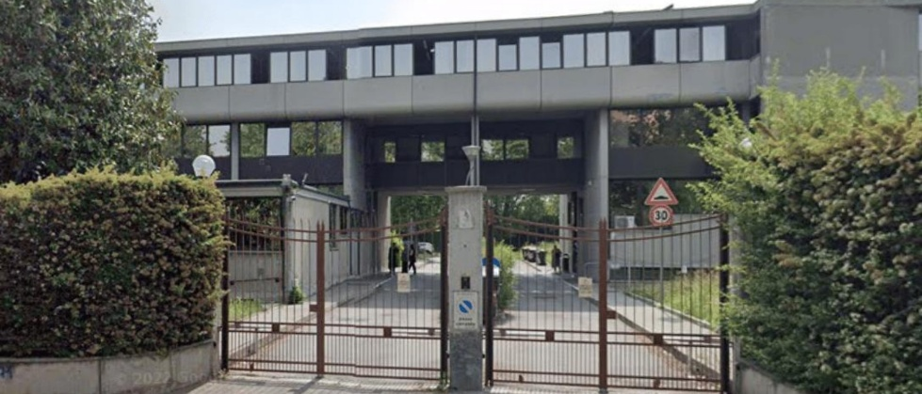

Time: | Meeting:
9:20am-10am | Meet Carmen Mecca, President of Tribunale per I Minorenni and Emma Avezzù, Prosecutor. Meeting with magistrates of the Tribunal, focus on judicial activities for children and adolescents in the first instance of judgment
10am-12pm  12:15pm-2:00pm | Spend the morning with members of the judiciary, senior members of staff and observing proceedings in Tribunale.  A brief remembrance of Paolo Vercellone, AIMJF president from 1990 to 1994  Scheduled visit to the "Centro per la Giustizia Minorile" and exchange with exchange with social services staff dedicated to supporting accused minors.
2:00pm | End of visit to Tribunale per i Minorenni and Centro per la Giustizia Minorile.
2:30pm | Final reflections and closure.

How to get there?

Palazzo di Giustizia di Torino
The Palace of Justice is located in one of the main streets of Turin, easily reachable by public transport and located near the Hotel recommended for study tour guests.

Tribunale per I Minorenni di Torino
The Juvenile Court is located in the southern part of the city, near the FIAT factory and well connected to the centre by public transport. Next to the Juvenile Court is the Centro per la Giustizi Minorile and the "Ferrante Aporti" detention centre for minors.

Judicial Office International Team

Nome Cognome – Roberta COLLIDA’
Email: roberta.collida@giustizia.it
Telephone: +39

AIMJF COORDINATION Contact’s Details | Email Address | Phone Number
Michele Termine | michele.termine@minoriefamiglia.org | +39 347 3500925

Recommended hotels for participants:

HOTEL DIPLOMATIC ****, via Cernaia 42 - Torino https://www.hotel-diplomatic.it

HOTEL DOCK MILANO ***, via Cernaia 46 – Torino https://dockmilano.bqhotel.it

NH HOTEL ****, Corso Vittorio Emanuele II 104 – Torino https://www.nh-hotels.com/en/hotel/nh-torino-centro?utm_campaign=local-gmb&utm_medium=organic_search&utm_source=google_gmb

For those needing assistance in booking hotel rooms, please contact the AIMJF coordinator at: michele.termine@minoriefamiglia.org

